**Image Kernels Explained Visually**

**Setosa** is a really cool visualization [Website](http://setosa.io/ev/image-kernels/) that shows the process of applying convolution kernels in even more detail.

Go ahead to: <http://setosa.io/ev/image-kernels/>

Below are two images, right one is a black and white image ( to reduce dimensionality ) where each pixel corresponding to the value represented in the left image.

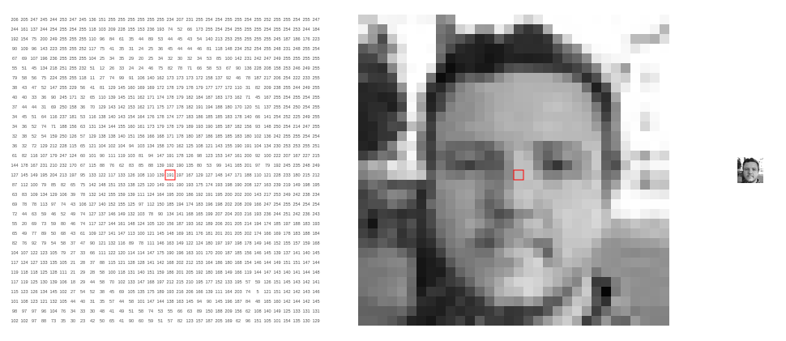

Using a kernel of 3*3 dimensions.

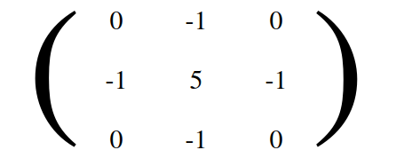

Below, for each 3*3 block of pixels in image on left, we multiply each pixel by corresponding value of kernel and then take the sum. This sum becomes the new pixel for the image on the right.

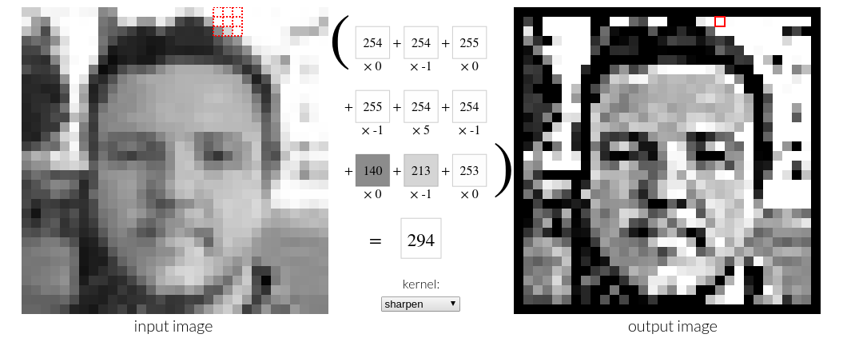

So you can move along and see how this is working by hovering above pixels.

You are encouraged to check out this website and play around of this; hopefully this gives you a good idea of the actual process.